***misr University for Science & Technology***

***College of Information Technology***

***IS-402 Internet Technology***

***Team members***

***Amr Osama Khafagy 200031891  
Rabea Ibrahim Ibrahim 200031640***

***Project name :-  
 CyberHack E-Commerce Platform***

***Supervised by:***

***Dr. Esmat Abdelmonem***

***Eng. Mai Mohamed***

***Fall 2024/2025***

***Home page***

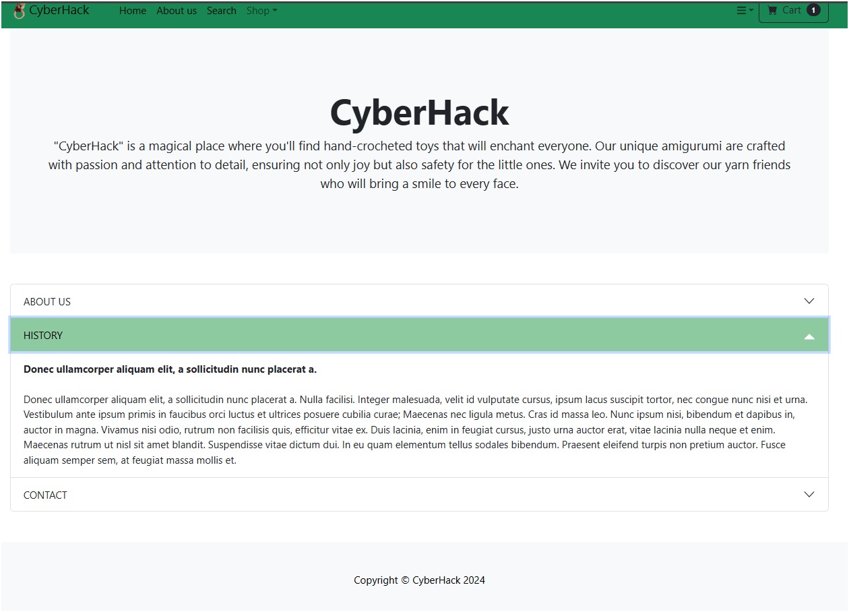***about Page***

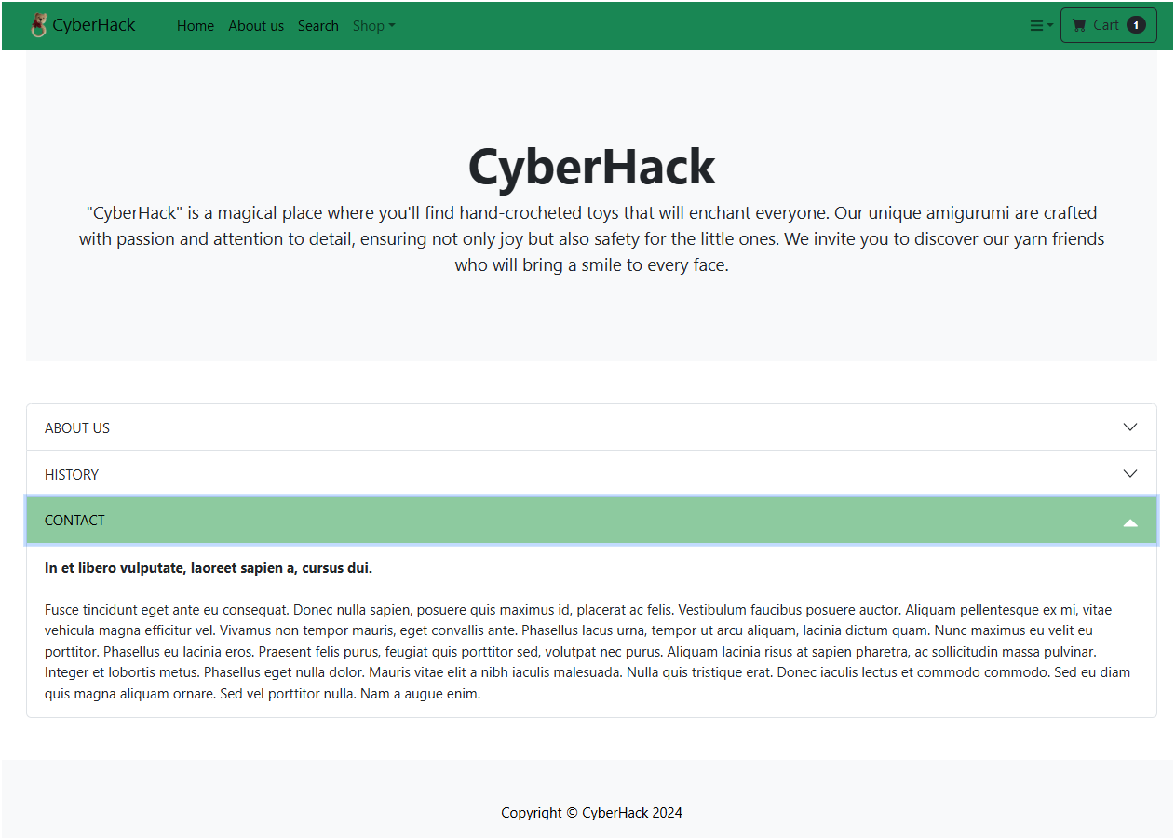

***Search Page***

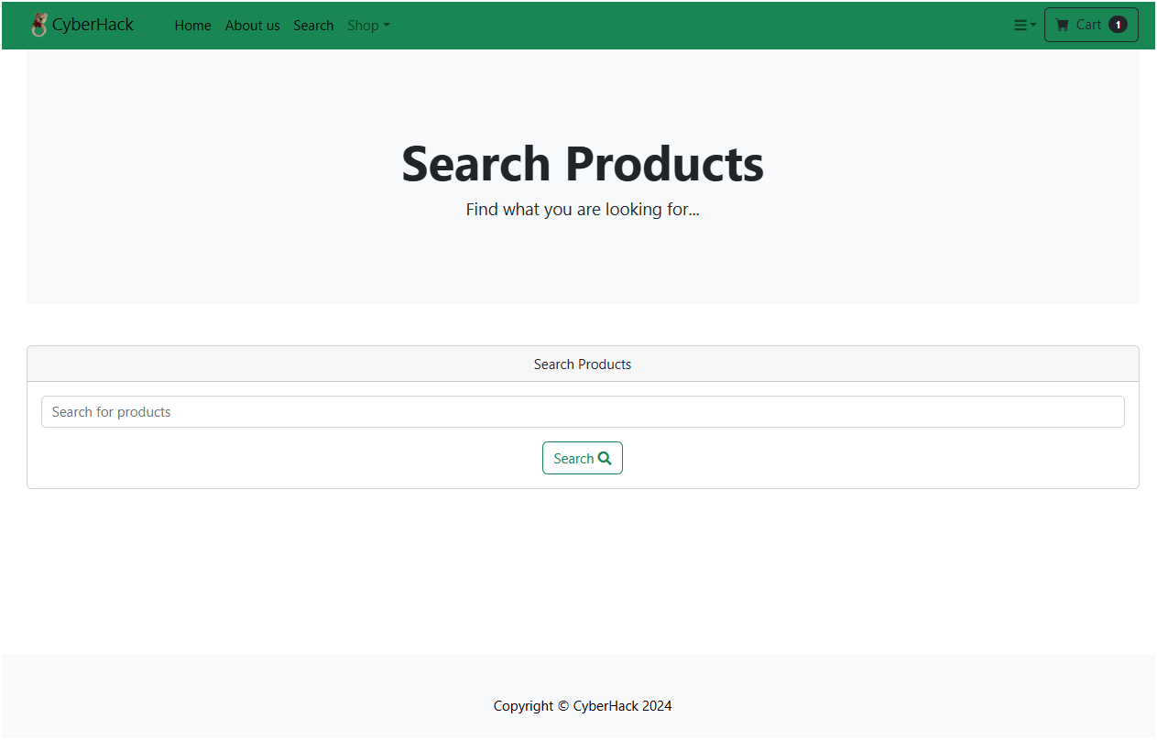

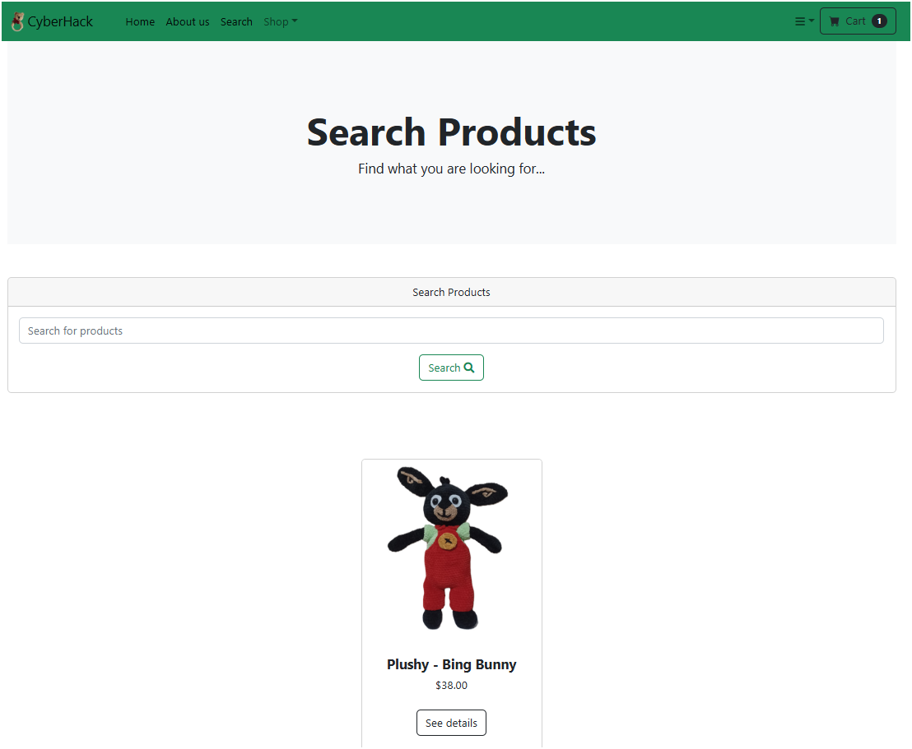

***Log in***

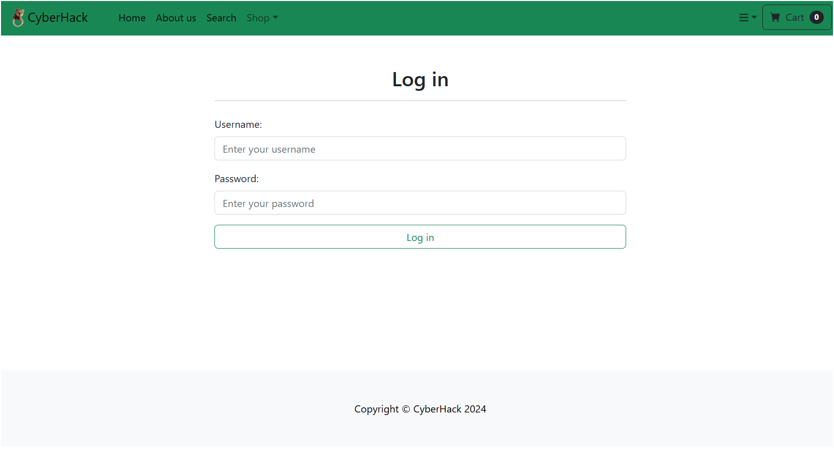

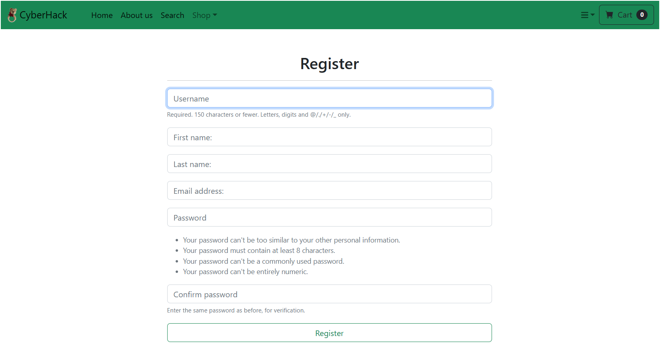***Sign up page***

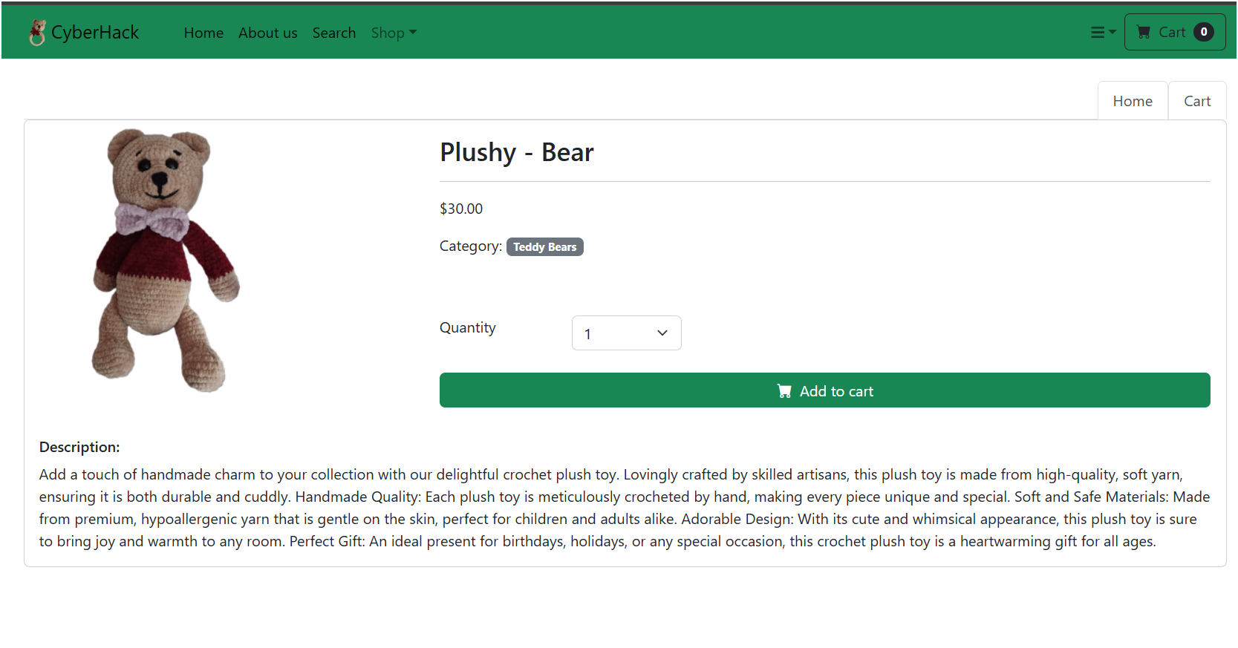***Buy Element***

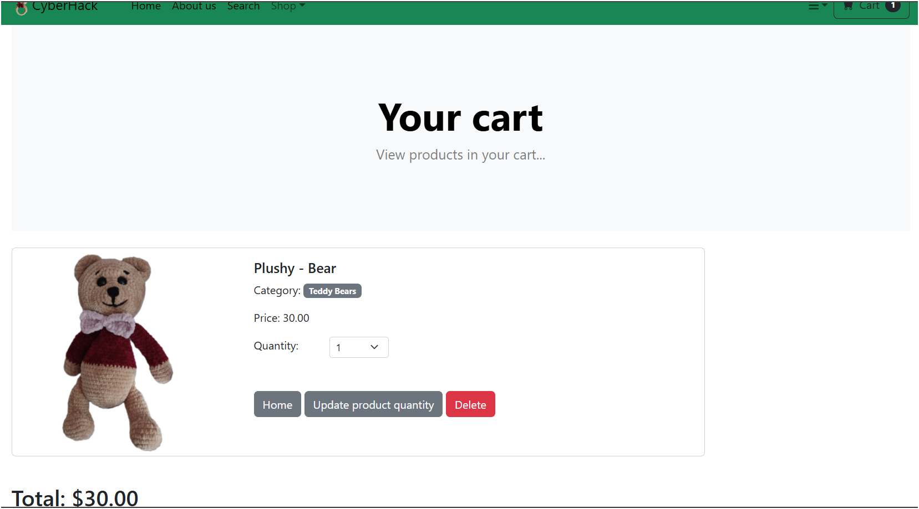***Cart page***

***Django administration database***

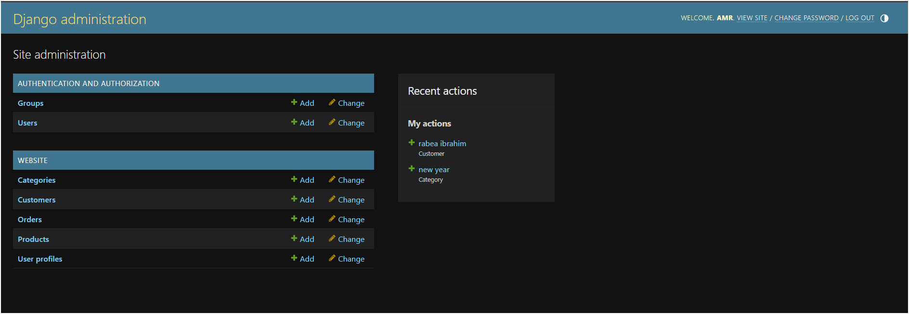

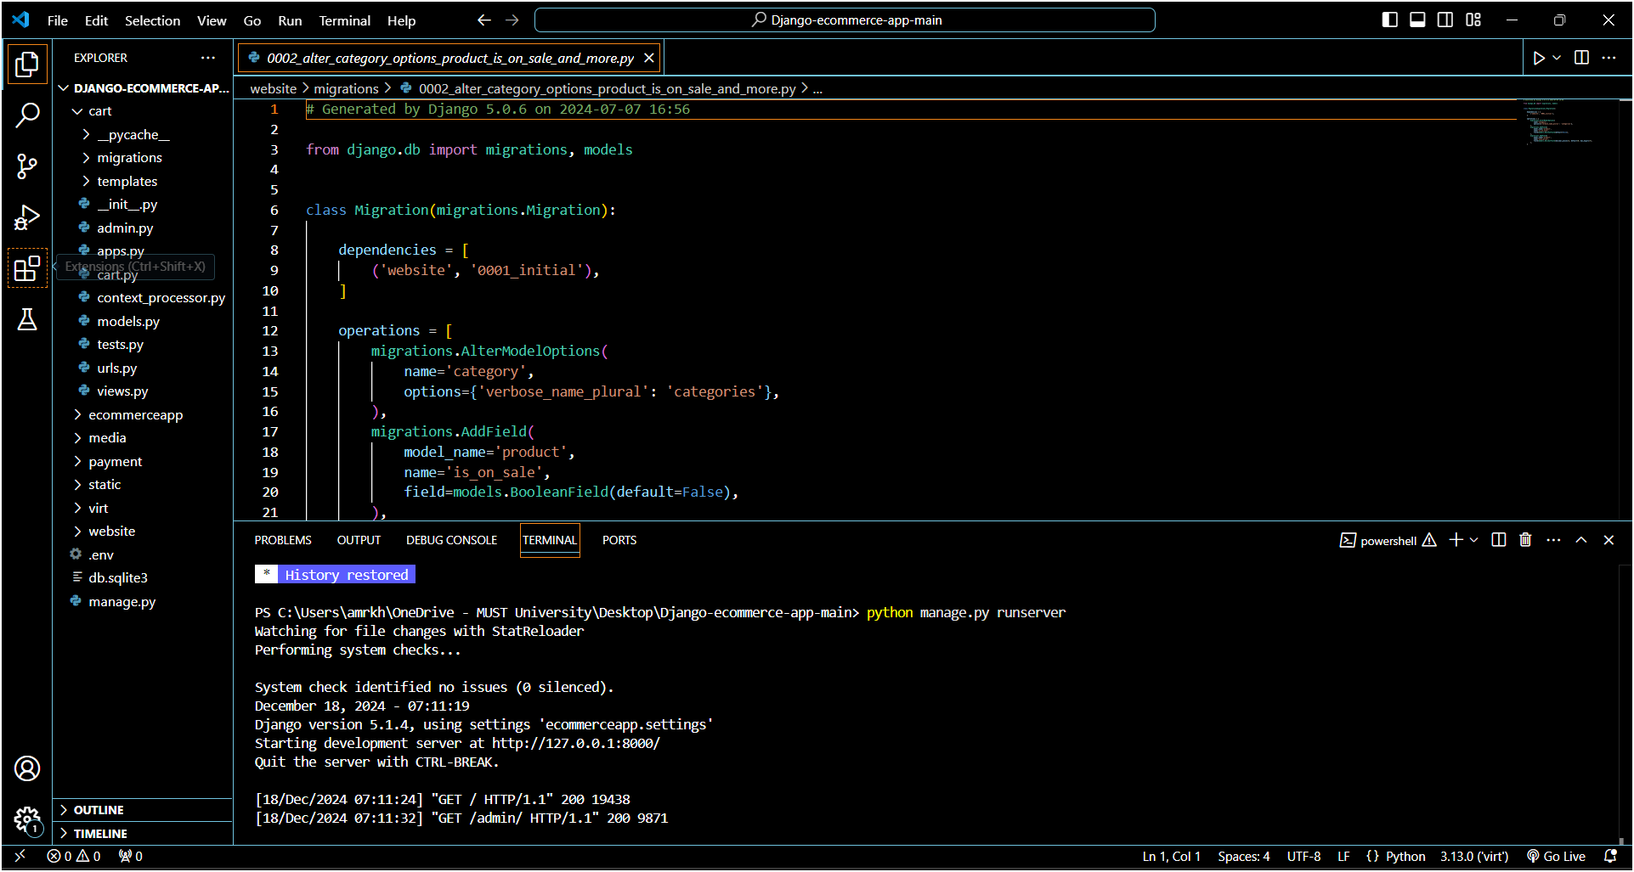Django code (vs code)